Every year Jews tell the story of the Exodus from Egypt at our seders. Every year we tell the same story, using the same words, from the same Haggadah. Even though we appreciate the story, it gets boring hearing it told the same exact way year after year after year. There is a Women's Haggadah, a Green Haggadah, a Gay Haggadah, and even a Socialist Haggadah, but (until now) you haven't been able to find a funny Haggadah. With sincere apologies to Eric Idle, John Cleese, and anyone who takes religion too seriously, here is the

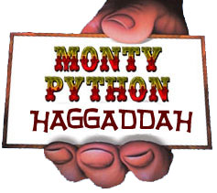
Please email suggestions for how to improve this Monty Python Haggadah to kayton@alum.mit.edu. This page may be reprinted for personal or family use, but it is NOT okay to reprint it or use it for commercial purposes without permission. (c) 2003, 2006. Thanks to the Coplan family for their additions to make this haggadah even funnier (well, it's funny if you happen to enjoy Monty Python.)
If you liked this Haggadah , you might also enjoy the Facebook Haggadah and Grad Student Haggadah by Carl Elkin, and don't miss If Moses Was on Facebook. produced by Shoot East.

Scene 1: In the Desert
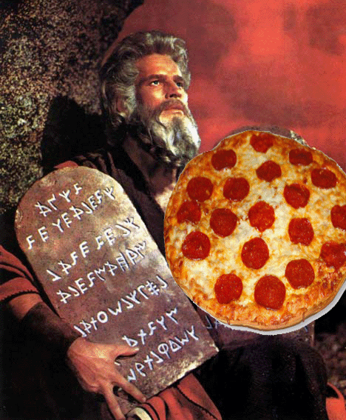
Moses is galloping (skipping on foot while clopping coconuts together to sound like hoofbeats) across the desert. He comes to a burning bush.
Bush: Halt! Who goes there!
Moses: A shrubbery! A talking shrubbery! One that looks
nice, but is not too expensive. It is a good
shrubbery. I like the laurels particularly.
Bush: Moses! Moses, Leader of the Israelites!
(Moses looks stunned, drops to his knees in awe and bows his head to the ground in front of the burning bush.)
Bush: Oh, don't grovel! If there's one thing I can't stand, it's people groveling.
Moses: Sorry--
Bush: And don't apologize. Every time I try to talk to someone, it's "sorry this" and
"forgive me that" and "I'm not worthy". What are you doing now!?
Moses: I'm averting my eyes, oh Lord.
Bush: Well, don't. It's like those miserable Psalms -- they're so depressing. Now stop it.
Moses: Yes, Lord.
Bush: Right! Moses, leader of the Israelites your people shall have a task to make them
an example in these dark times.
Moses: Good idea, Lord!
Bush: Of course it's a good idea! Behold! This is your task - to cut down the mightiest
tree in the forest with a herring.
Moses: It shall be as you command. But should I use a schmaltz herring, matjes
herring, or herring with sour cream and onions?
Bush: Forget it. Instead, your task shall be to deliver the Israelites from bondage in
Egypt.
Moses: Wouldn't you rather have me deliver a pizza instead?
Scene 2: In Egypt
Moses: I never wanted to do this job of deliverance in the first place. At least delivering pizzas pays good tips! I wanted to be a lumberjack, even though it’s a bit hard doing that in the desert. (Israelites sing):
Oh, we're Egyptian slaves. It's not OK.
We work all night and we work all day.
We quarry blocks and make mud bricks
And want to run away!

Scene 3: Asking Pharaoh to leave
Moses approaches Pharaoh and his advisors to ask for permission for the Israelites to leave Egypt.
Pharaoh and his advisors say, "Ni! We are the keepers of the sacred words: Ni, Ping, and Neeee-wommmm! We want a shrubbery!!!"
Moses says, "I already found a shrubbery in the desert. It told me it was God, and told me to deliver the Israelites from bondage in Egypt."

When Pharaoh asks for proof that Moses speaks for God, he shows Pharaoh the holy hand grenade and Aaron pulls the holy pin, making mincemeat of half the advisors.

Scene 4: The Ten Plagues
Killer rabbits
The Spanish Inquisition
1000-ton weights
Crunchy frogs
Giant badgers
Dead parrots
Silly walks
Plague six. There IS no plague six!
Spam.
The killing of the first born

The morning after the final plague, the Egyptian garbage collectors roam the streets calling, "Bring out your dead!" People bring corpses of plague victims to the dead cart.

When they start to pick up one body, one of the collectors says, "Wait a bit. He's not dead. He's just resting." A lightning bolt comes out of the sky, hitting the body and killing it. The collectors smile and heave it onto the cart.
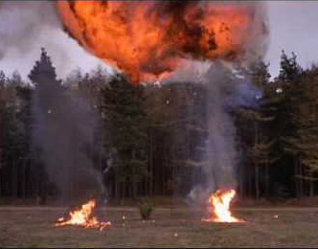
Scene 5: The Exodus

Aaron (addressing the assembled Israelite multitude):
We need to sneak out of Egypt quickly without Pharaoh's army noticing. In this demonstration, we hope to show how to leave Egypt without being seen. This is Miriam of the Tribe of Levi. She can not be seen. Now I am going to ask her to stand up. Sister Miriam, will you stand up please?
In the distance Miriam stands up. There is a clap of thunder and Miriam crumples to the ground.

Aaron: This demonstrates the value of not being seen.
Stop! This is getting too silly!

Scene 6: Arriving at the Red Sea
The Red Sea guard challenges the fleeing Israelites as they arrive.
Guard: None shall pass. What is your name?
Moses: Moses.
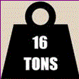
Guard: What is your quest?
Moses: To reach the Promised Land.
Guard: What are your favorite colors?
Moses: Blue and white.
Guard: You may pass.

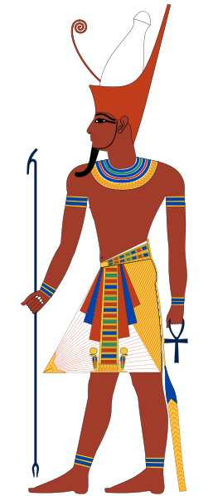
The Israelites pass through the Red Sea. Now Pharaoh's army approaches, led by Rameses.
Guard: What is your name?
Rameses: Rameses, Pharaoh of Egypt
Guard: What is your quest?
Rameses: To bring back the fleeing Israelite slaves.
Guard: What is the capital of modern-day Abyssinia?
Rameses: I don't know that.

The guard unleashes a flood of water onto Rameses and the army, drowning them all.

Rameses: Auuugh!

Aaron watches awestruck, then asks Moses how he was able to answer the questions so well. Moses says, "You have to know these sorts of things when you’re a leader of the Israelites, you know."

Narrator: Forty years later, after wandering around in the desert searching for the Holy Grail, Moses and Joshua stumble across a dragon ship and sail across the river Jordan to swelling music, but just as everything looks like there will be a happy ending ....

Moses: No afikomen here. Let's head back.
Scene 7: The seder plate
To help us remember the story of the first Passover, we have assembled various symbolic foods on a Seder plate. There's egg and spam; shankbone and spam; greens and spam, bitter herbs and spam, charoses and spam, and spam, and spam spam egg and spam; spam spam spam matzoh and spam; spam spam spam spam spam spam baked beans spam spam spam... Spam! Lovely spam! Lovely spam!

But I can't eat spam, it's not kosher!

I'll eat yours, dear. I'm Reform.
Scene 8: The Four Questions
Setting: A dusty street in a small Egyptian city.
Moses: It's time to ask the five questions.
Aaron: Four, sir! It's FOUR questions.
Moses: Right. Thou shalt ask four. No more. No less. Four shall be the number thou shalt ask, and the number of the asking shall be four. Five shalt thou not ask, nor either ask thou three, excepting that thou then proceed to four.
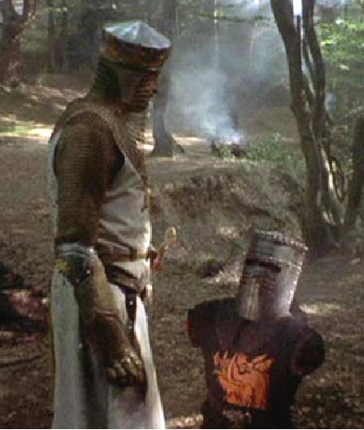
Enter King Arthur and the Black Knight. King Arthur fights the Black Knight. First King Arthur cuts off the Black Knight's right arm, but he keeps on fighting. Then Arthur cuts off the Black Knight's left arm, followed by his right leg, and then finally cuts off his left leg. The Black Knight keeps fighting.
King Arthur turns toward the audience with a puzzled look and asks, "Why is this knight different from all other knights?"
Pause. Let the audience groan. Then continue. Yes, we know that's only one question, but who's counting?

Scene 9: Dinner
It's time to eat dinner. While eating, make sure to defend yourself against the possibility that the person to your right will attack you with a banana.

Scene 10: The Afikomen
The children are sent out of the room to find the Afikomen. They return, shouting.
Children: An afikomen! An afikomen! An afikomen! We've got an afikomen!: We have
found an afikomen, may we eat it?
Father: Eat it! Eat!
Mother: How do you know it is an afikomen?
Children: It looks like one. It has warts on it. And it turned me into a newt!

Scene 11: Elijah's Cup

Well, it's just after eight o'clock, and time for to open the door for Elijah's penguin. (Participant opens the door and a penguin waddles in. The penguin explodes.)

Scene 12: Conclusion

We conclude tonight's program with the question, “Is there life after death?” And here to discuss this question are three dead people: the late Pharaoh Ramses, former ruler of the kingdom of Egypt, circa 1400 BCE; the late Moshe ben Amram, tribal spokesperson and record holder for longest road trip across the wilderness; and putting forward the view of the Powers that Be, the prophet Elijah the Gileadite.
Gentlemen, is there life after death or not? (Prolonged silence)

Well there we have it! Three say "No". On next week's program we'll be discussing the question: Does the state of France have a right to exist?

And until then, good night.
***************************************************************************************************
Please email suggestions for how to improve this Monty Python Haggadah to kayton@alum.mit.edu. This page may be reprinted for personal or family use, but it is NOT okay to reprint it or use it for commercial purposes without permission. (c) 2003, 2006. Thanks to the Coplan family and David Frank for their additions to make this haggadah even funnier (well, it's funny if you happen to enjoy Monty Python.)
If you liked this Haggadah , you might also enjoy the Facebook Haggadah and Grad Student Haggadah by Carl Elkin, and don't miss If Moses Was on Facebook, produced by Shoot East.

